ASSIGNMENT 2

TEAM ID: PNT2022TMID04321

Student name: S. Harisudhan

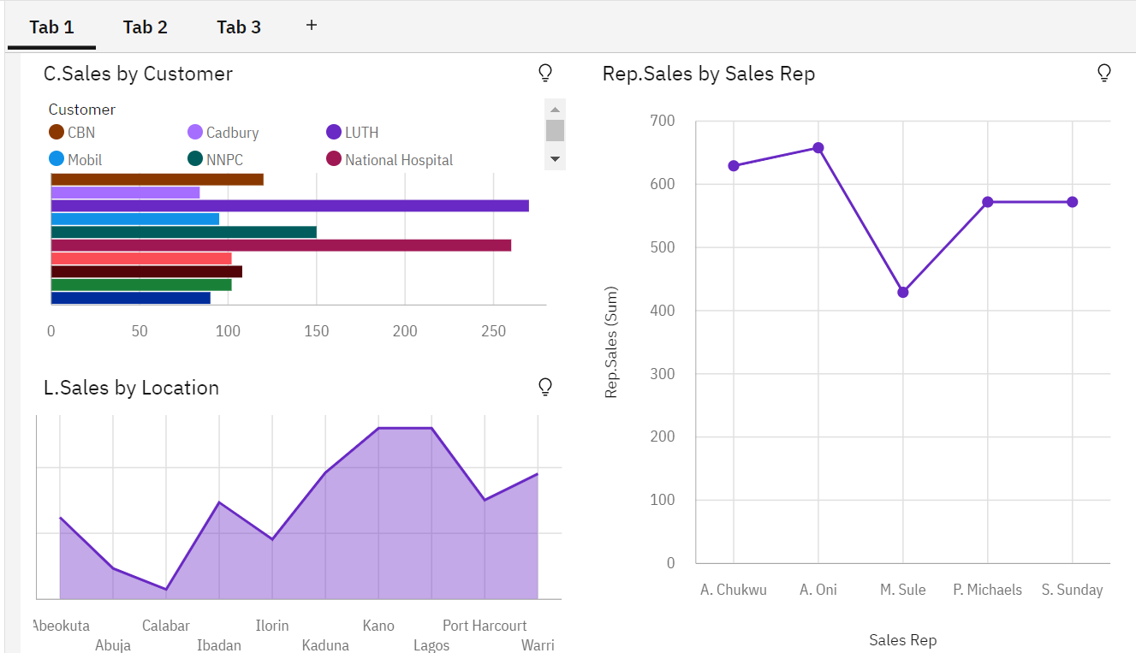

<https://us1.ca.analytics.ibm.com/bi/?perspective=dashboard&pathRef=.my_folders%2FASSIGNMENT2%2Fpage1&action=view&mode=dashboard&subView=model000001837f9bbf2f_00000000>

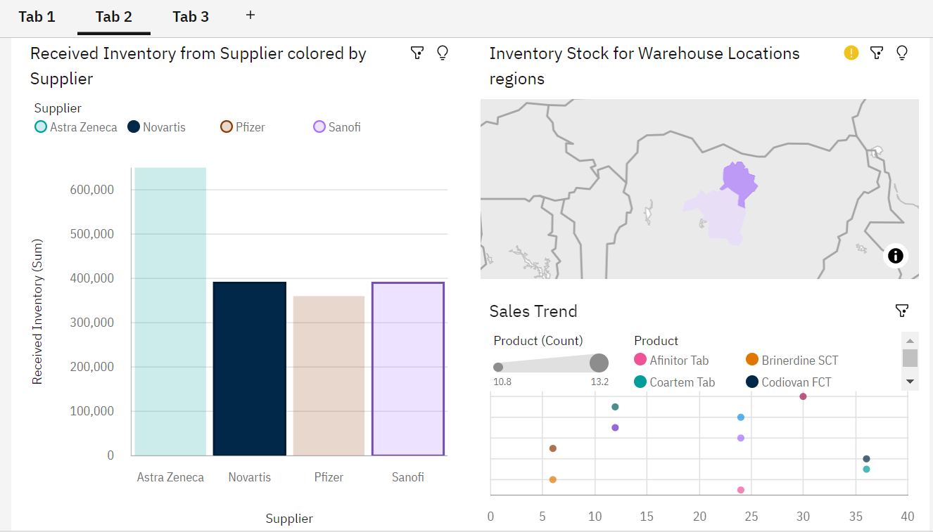

<https://us1.ca.analytics.ibm.com/bi/?perspective=dashboard&pathRef=.my_folders%2FASSIGNMENT2%2Fpage2&action=view&mode=dashboard&subView=model000001837faf3b13_00000000>

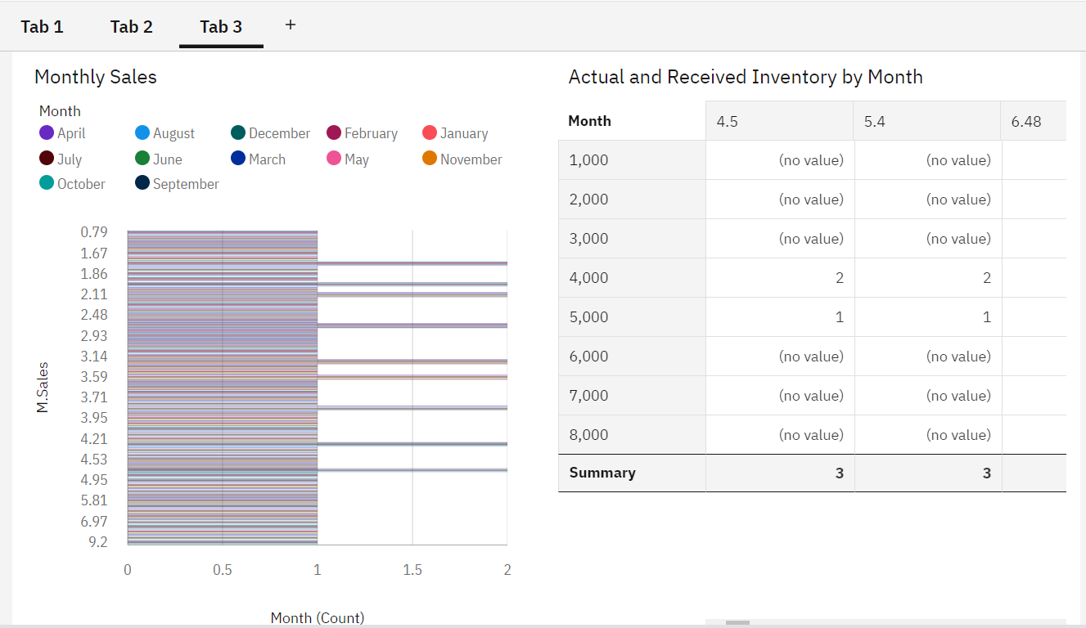

<https://us1.ca.analytics.ibm.com/bi/?perspective=dashboard&pathRef=.my_folders%2FASSIGNMENT2%2Fpage3&action=view&mode=dashboard&subView=model000001837fbf355d_00000000>